**Automatic License Plate Recognition and Challan Generating**

***Presented by***

**MAHRUKH MALIK [1003-FBAS/BSSE/F09]**

***Supervised by***

**Ms Zakia Jalil**

**Department of Computer Science and Software Engineering**

**Faculty of Basic and Applied Sciences**

**International Islamic University, Islamabad**

**2013**

**Contents**

* **Introduction…………………………...……………..…………..……....1**
* **Literature review……………….…………………………………..…….2**
* **Problem statement…………………..………..........................................2**
* **Scope of new system………………………….........................................2**
* **Outcome of work……………………………............................................3**
* **Methodology…………………….………..................................................3**
* **Algorithms…………………………..…………...........................................3**
* **Tools…………………………….................................................................4**
* **References…………………………….......................................................5**

**INTRODUCTION:**

License plate recognition (LPR) is a mass surveillance method that uses optical character recognition on images to read vehicle registration plates. There is a need for intelligent traffic management systems in order to cope with the constantly increasing traffic on today’s roads. That’s why Automatic license plate recognition system (ALPR) is a key research area of computer vision and image processing. It has been utilized in many applications like traffic law enforcement, border security, preventing vehicle thefts, automatic toll collection, automatic parking control, automatic challen generating and vehicular crime prevention. Information about current situations can be automatically extracted by image processing algorithms.

The LPR (License Plate Recognition) system consists of LPR devices, a central device and a network link between the devices. The LPR devices are usually installed at roadside and are composed of camera units that continuously take roadway images and a controller which recognizes or judges all the character and figure on license plates, the vehicle type such as private or business and the vehicle color or any further information is hence forth by image processing algorithms.

In this project we will present an approach to get one integrated system that can recognize and identify the license plates of vehicles whenever a traffic violation occurs, such as speeding or running a red in more accurate and efficient manner. After recognizing license plate number we will generate challan and that challan send to that person on cell phone.

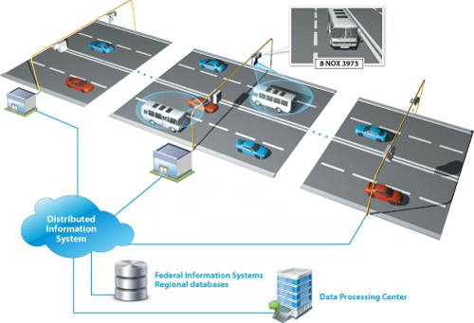

**Figure -1.1**

**LITERATURE REVIEW**

License Plate Recognition is similar to Automatic Number Plate Recognition (ANPR), which was first invented by the Police Scientific Development Branch (UK) in 1976. The system gained much interest in last decade with the improvement in digital cameras and computational power as it involves the ability to extract and then recognize the numeric and alpha numeric characters from the image of the vehicle’s number plate. Deploying smart cameras for the purpose of video based traffic surveillance has the advantage of allowing direct on site image processing tasks. It can use existing closed-circuit television (CCTV) camera or general video cameras. LPR can be used to store the images captured by the cameras as well as the text from the license plate, with some configurable to store a photograph of the driver.

Generally, license plate recognition consists of two separate parts. First, plates have to be located within the image, termed license plate detection followed by license plate character recognition, determining the plate number. These two basic modules are generally further subdivided into four modules i.e. image acquisition, license plate extraction, character segmentation, and character recognition.

In the first module, image can be acquired by using a video camera with a grabber [1], an analogue camera with a scanner or a high resolution digital camera [2]. So a high-speed shutter camera and a frame grabber form the front-end of the system. The camera delivers images of vehicles passing by. The image is then digitized. The optical resolution of the images is assumed to be 439 x 510 pixels [3].

There are several common algorithms to locate the license plate. Searching algorithms mainly rely on colour information and special signs. Widely used procedures that are solely based on image processing are as Hough transform, Top-Hat and Bottom-Hat filtering (highlights the black-white transitions) [4] Binary morphology algorithm (for example: classical Otsu method) [5] Edge finding methods (Sobel, Laplacian, Roberts, Prewitt, Canny operators) [6] [5] [7]. These methods depend upon the colour of the background and characters. Region-growing algorithm (RGA): By using a recursive region-growing algorithm, the dark regions (license plate symbols) surrounded by light areas (background of the license plate) can then be classified. Each region has a unique position and dimensions. [8] Checking: colour, size, and ratio. Presently, there are several common algorithms for the segmentation of license plate characters, such as direct segmentation, template matching, projection and cluster analysis. [8] In the direct segmentation algorithm [9], the license plate characters are segmented directly according to the prior knowledge of the width of characters and spaces between characters. This algorithm is simple and rapid. But the left and right side of characters region must be located accurately before using it. So it is reliable to the effect of license plate location. [7] In the template matching algorithm [10], a template is used to scan the image of license plate to find the maximum difference value of the number of white points between the region of character and the region of space between characters. This algorithm can avoid falsely segmenting characters. [4] In the projection algorithm with template matching [11] [12], the number of white points in vertical direction is counted and recorded.

The character region has more white points than the region of space between characters. By detecting the trough of white points between characters, the spaces can be located and then the boundary of characters can be located. Character Recognition uses the basic methods as pattern recognition and Neural Network based recognition systems. [8] In Pattern Recognition method [13], the character can be written differently so the pattern may vary. This may give false result. [7] Neural Network based method [14][15], this system needs training to recognize the characters. In this computational time depends on the training set and also it is very expensive.

**PROBLEM STATEMENT:**

Most license plate recognition systems in operation today use special hardware like high resolution cameras or infrared sensors to improve the input quality and they operate only in **controlled settings**.

License plate extraction is the second and most important module of an LPR system. Literature review suggests that color histogram technique was unsuccessful in diverse lighting conditions. A comparison of different LP detection and recognition systems is difficult as each one is subject to differing prerequisites. Furthermore, the lack of a common evaluation database makes evaluations and comparisons unfair.

Basically today there is challan generating is done manually this is problem now our system will generate challan automatically from image and after that our system will send that challan automatically to that person on cell phone.

**SCOPE OF NEW SYSTEM:**

This new system will recognized license plate number through federal and regional wanted vehicle databases, as well as through your own local databases. This system is for standardized number plate not for non-standardized number plate.

All license plates recognized successful match in database will result in sending a notification message. If a recognized license plate number obtains a match with an external (federal or regional) or internal (real-time tracking) database, an audible notification is initiated, and an alarm message appears on screen displaying the vehicle license plate number and relevant information from the database individual details of the vehicle. An alarm message can also be configured to display whenever a traffic violation occurs, such as speeding or running a red light. From this information our system will generate challan and that challan will automatically send to person on cell phone with basic information.

The alarm notification window is provided with a confirmation button that can be used to monitor operators' performance. In order to confirm that an alarm has been handled, the operator is required to click the alarm confirmation button within a set timeframe after the alarm is initiated. As a result, operators’ work performance can be evaluated by checking how many alarms they confirm, how long it takes them to confirm, and how many alarms they miss.

**OUTCOME OF WORK:**

The objective is to propose fast and efficient application software which can be used for the recognition of car license plates. The software will be divided into smaller modules i.e. ***license plate extraction*** from the image/video, ***segmentation of the characters***, ***recognition of the characters*** and then finally the integration of the results.

Although Automated License Plate Recognition (ALPR) or License Plate Recognition (LPR) is not a new idea and from many years it has been implemented in various countries like UK, Australia, Germany, Belgium, and Portugal. But the objective of this research work is to come up with both a time and money saving real time tested and verified software which can be used by law enforcement agencies and private organization for improving the traffic management and vehicle security.

This system will monitor operator performance and monitor vehicles where and when rule violation occur. When such incident occur than our system will generate automatic challan that challan will automatically send to specific person through SMS

**METHODOLOGY USED:**

Image Acquisition

**Figure -1.2**

**Image Acquisition:**

In the proposed methodology, a high resolution digital camera is used to capture the image, with a prior knowledge of fixed size, angle and distance which improves the precision of the system. The images are captured in RGB format so it can be further process for the number plate extraction. Pre-processing of the captured image is performed such as RGB to grey scale conversion, noise filtering, Linearization process.

Filtering is employed to wipe out objects that do not suit some specific features. In the proposed approach, the route of filtering begins by first identifying every region. A set of white pixels is termed a region if they are eight-connected pixels. Once every pixel of a region is spotted, the region is tested for its size and shape. The intention behind filtering operation is to select the regions that can give out as possible license plate boundaries and eliminate the others by filling black colours in their place.

**Plate Extraction:**

From various literature sources, there appears to be two methods that can be adopted for locating a number plate. The first of these methods is based on threshold the image so that there is a contrast between the number plate characters and the background.

This plate localization algorithm is based on combining textural characteristics of license plate and morphological operation sensitive to specific shapes in the input image with a good threshold value by which the license plate is located. A fine percentage of localization of License plates is achieved by this algorithm. This is a better performing algorithm for License Plate Images with complicated background. License Plate consists of many vertical edges because it consists of Borders, Characters, and Digits.

The anticipated methodology then employs Sobel edge detector as it offers additional precise outcome. The Sobel edge detector utilizes a 3x3 mask, which is applied on the input image to provide the consequential edged image. This stage reduces algorithmic difficulty. If we can identify half of the vertical edges, four corners of the license plate can then be traced.

**Character Segmentation:**

The segmentation of a line of characters is an important problem emerging in the license plate recognition (LPR) systems. The objective is to partition image into segments with isolated characters which serve as an input of the Optical Character Recognition (OCR) system.

Character segmentation is the procedure of extracting the characters and numbers from the license plate image. Diverse aspects make the character segmentation task complicated, like image noise, plate frame, space mark, plate’s rotation and light variance. The plate image determined using the above steps is converted into binary image. The binary image is segmented into isolated characters by vertical projection profile histogram.

This is done using adaptive threshold with a window of size11 (This is selected using trial and error). Then a process of noise removal is applied. This is done by getting the connected components from the binary image based on the 8-neighbourhood using flood fill. For every component, we decide if it’s a noise or not based on the aspect ratio of the component and based on the number of pixels in that component. This is based on the fact that the characters of the plate have a certain range of aspect ratio and a certain range of number of pixels. After removing the noise components a maximum filter is applied to make the effect of thinning the characters to make sure that no two components are merged. This is followed by a horizontal projection, to detect the boundaries between the characters to be able to cut them individually. The peaks in this projection correspond to the gaps between the characters. So, we get all of these peaks and a rejection process is applied also, since a true plate has a fixed range of gaps between characters. [20]

After this the characters are cut according to the peaks of the previous projection. Then another set of measures are computed to reject the false characters that may still exist after the noise removal operation.

**Character Recognition:**

After the segmentation of elements (characters and numbers), the final module in the recognition process is character recognition. In the last module, character recognition is done by utilizing template matching technique.

A basic method of template matching uses a convolution mask (template), tailored to a specific feature of the search image, which we want to detect. This technique can be easily performed on grey images or edge images. The convolution output will be highest at places where the image structure matches the mask structure, where large image values get multiplied by large mask values.

Each segmented character from the previous module will be matched with the stored templates of the character. These stored templates consist of pixels. These pixels are termed as test point. There are two types of test point. One test point is called white test point and the other is termed as black test point. The white area of the character image from segmentation stage is tested by the white test point. Black test point is used to test the black area of the character image. The result of the test point is given by:

Matched Point = White test points fall in white pixel of the character image and black test points fall in the black pixel of the character image. A predefined value has been allocated for black test point (85%) and white test point (90%). The character will be matched if the result is larger than these predefined values.

**Automatic challen Generating:**

Whenever a traffic violation occurs, such as speeding or running a red than recognize number plate there is database record from where automatically match license plate number and after matching number plate generate challen as per rule of violation here we use SQL data base . Using android application our system sends automatically challan on cell phone and there is status on database that checks challan is paid or unpaid.

**ALGORITHMS:**

The following tentative algorithm is designed to complete the project but changes can be made as per the requirements.

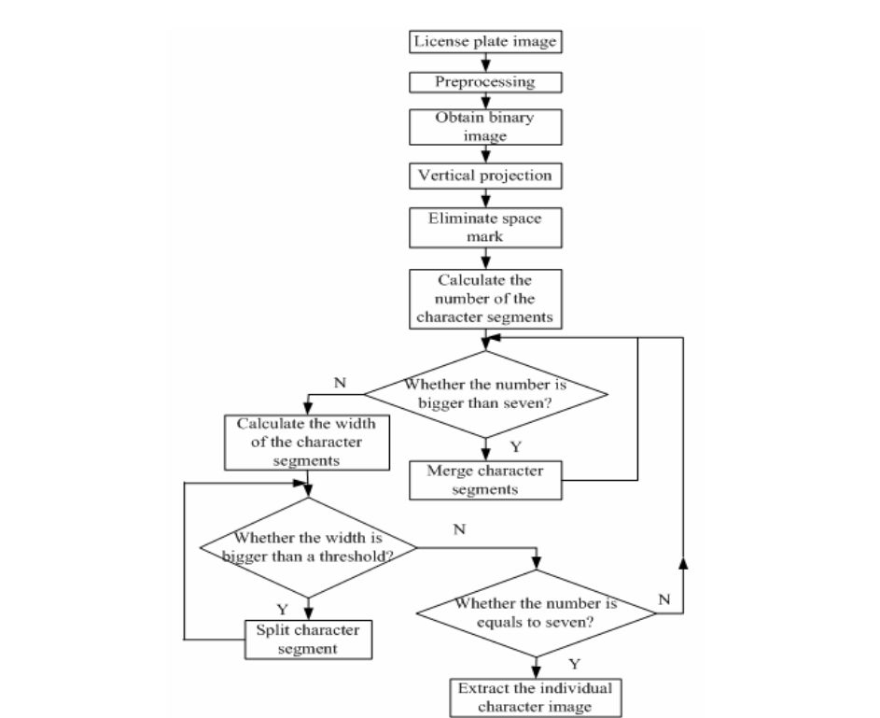

**Figure-1.3**

* Image processing concepts
* Plate localization – responsible for finding and isolating the plate on the picture.
* Region-growing algorithm (RGA)
* Plate orientation and sizing – compensates for the skew of the plate and adjusts the dimensions to the required size.
* Normalization – adjusts the brightness and contrast of the image.
* Character segmentation – finds the individual characters on the plates.
* Optical character recognition.

**TOOLS:**

Following are the list of tools and technologies that we can use in our project.

* Linux
* SQL database
* Python
* PyCK
* RPC
* OPENCV
* Mat lab

**REFFERENCES:**

[1] Bremananth, R.; Chitra, A.; Seetharaman, V.; Nathan, V.S.L., “A robust video based license plate recognition system” IEEE Proceedings of ICISIP, 2005, Page(s): 175 – 180.

[2] Sarfraz, M.; Ahmed, M.J.; Ghazi, S.A. “Saudi Arabian License Plate Recognition System” IEEE 2003, Page(s): 36 – 41.

[3] http://alexandria.tue.nl/extra2/afstversl/E/510631.pdf

[4] Automatic Car Plate Recognition Using a Partial Segmentation Algorithm, Fernando Martin, David Borges, Signal Theory and Communications Department, Vigo University, Pontevedra, Spain

[5] License Plate Recognition - Final Report, Pierre Ponce, Stanley S. Wang, David L. Wang.

[6] License plate recognition system, David Chanson and Timothy Roberts, Department of Electrical and Electronic Engineering, Manukau Institute of Technology, Auckland

[7] Robust License-Plate Extraction Method under ComplexImage Conditions, Sunghoon Kim, Daechul Kim, YounbokRyu, and Gyeonghwan Kim, Dept. of Electronic Engineering, Sogang University, Seoul, Korea

[8]Optimization of vehicle licence plate segmentation and symbol recognition, R.P. van Heerden and E C. Botha, Department of Electrical, Electronic and Computer engineering, University of Pretoria, South Africa

[9] Hongwei Ying, Jiatao Song, XiaoboRen” Character Segmentation for License Plate by the Separator Symbol's Frame of Reference” 2010 International Conference on Information, Networking and Automation (ICINA)

[10] Deng Hongyao, Song Xiuli “License Plate Characters Segmentation Using Projection and Template Matching”, 2009 International Conference on Information Technology and Computer Science.

[11] ShuangQiaol , Yan Zhul , Xiufen Li l , Taihui Liu2 ,3, BaoxueZhangl “Research of improving the accuracy of license plate character segmentation” 2010 Fifth International Conference on Frontier of Computer Science and Technology

[12] Dong- June Lee, Seong-Whan Lee” A New Methodology for Gray-Scale Character Segmentation and Recognition”, 1995 IEEE

[13] Yucheng Li, Yisong Liu Mushu Wang “Study and Realization for License Plate Recognition System”,2009 IEEE.

[14] c. Nelson Kennedy Babu, Krishnan Nallaperumal “A License Plate Localization using Morphology and Recognition”, 2008 IEEE.

[15] http://www.ampublisher.com/April%202010/IPCV-1004-014.pdf

[16] http://ijaest.iserp.org/archieves/9.2-A16-30-11/Vol-No.6-Issue-No.1/3.IJAEST-Vol-No-6-Issue-No-1-A-Novel-Approach-for-Indian-License-Plate-Recognition-System-010-014.pdf

[17] http://ijaest.iserp.org/archieves/9.2-A16-30-11/Vol-No.6-Issue-No.1/3.IJAEST-Vol-No-6-Issue-No-1-A-Novel-Approach-for-Indian-License-Plate-Recognition-System-010-014.pdf

[18] http://paper.ijcsns.org/07_book/201107/20110709.pdf

[19] http://www.sdiwc.net/digital-library/web-admin/upload-pdf/00000110.pdf

[20]<http://www.google.co.uk/url?sa=t&rct=j&q=research+in+character+segmentation+in+license+plate+recognition&source=web&cd=6&cad=rja&ved=0CFcQFjAF&url=http%3A%2F%2Finf.ucv.ro%2F~ami%2Findex.php%2Fami%2Farticle%2Fdownload%2F388%2F351&ei=9d5FUff9OMvP4QS8m4DQAw&usg=AFQjCNHYBH2tPOLsUZaQXaL8UIWTMD7l6w>

[21][http://www.ampublisher.com/April%202010/IPCV-1004-014.pdf](http://www.ampublisher.com/April 2010/IPCV-1004-014.pdf)

[22]http://www.emgu.com/wiki/index.php/License_Plate_Recognition_in_CSharp